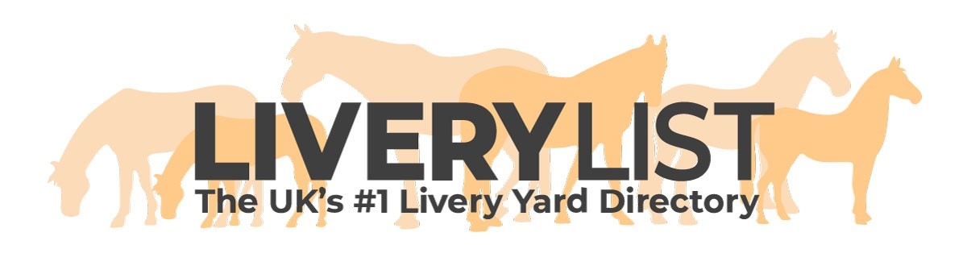
Health and Safety Policy Template
The template below is a guide for yard owners as to the type of policy you need to produce as a Health and Safety policy for your yard. All yards are different so its important to ensure your policy is tailored to your yard and covers any activities you offer- such as instructions, events, clinics- and deals with these accordingly within a singular policy. There are personalisations required where indicated in bold.

A copy of the policy should be retained on the yard to be referred to as and when necessary by the relevant people.

Health and Safety Policy
(enter yard name)

Target Audience: All livery clients, yard visitors, staff, yard manager, visiting services or trades people (amend as necessary)
Purpose: To ensure health and safety of target audience
Effective From: (enter date)
Review Date: (enter date)

Statutory Legal Requirements - Health and Safety Work Act 1974

This document is a health and safety policy for the purpose of making our clients and visitors (amend as necessary) aware of health and safety. It is the mission of (enter yard name) to make every reasonable step to keep all clients, visitors and the general public (amend as necessary) safe. (Enter yard name) will identify the duties and responsibilities that you as a client or visitor have to comply with to protect you and others from any hazards and risks in your riding or yard activities.

Health and Safety Policy Statement:
(Enter yard name) is strongly committed to encouraging all clients and visitors to take part in a range of equestrian activities in which the health, wellbeing and safety of each individual is always our paramount concern.

Health and Safety Policy:
Health and Safety is everyone’s responsibility. In order to create a safe environment for clients, visitors and staff at our yard we encourage you to familiarise yourself with this policy, follow sensible rules for safe practices, and exercise common sense. We undertake risk assessments to anticipate potential hazards at all Club events, and reasonable measures have been put in place to address and reduce these risks as far as is reasonably possible.
• A Hazard is: anything with the potential to cause harm.
• A Risk is the chance that someone will be harmed by the hazard.
• A Risk assessment is a formal recorded process to weigh up the suitability and safety of an activity identifying hazards and taking appropriate action to prevent harm or injury.

(Enter yard name) is committed to the following duties: (amend as necessary)
• Undertake regular, recorded risk assessment of the activities undertaken at (enter yard name).
• Create a safe environment by putting health and safety measures in place as identified by any assessment.
• Ensure that all visitors, clients and staff are aware of, understand and follow the health and safety policy.
• Appoint a competent staff member to assist with health and safety responsibilities.
• Ensure that normal operating procedures and emergency operating procedures are in place and communicated to all assisting members on the day of yard activities.
• Provide access to adequate first aid at all times.
• Report any injuries or accidents sustained during any activity at (enter yard name)
• RIDDOR Reporting
All incidents can be reported online but a telephone service is also provided for reporting fatal/specified, and major incidents only - call the Incident Contact Centre on 0345 300 9923 (opening hours Monday to Friday 8.30 am to 5 pm) 4
Health and Safety Executive. 900 Pavilion Drive Northampton Business Park Northampton NN4 7RG Fax: 01604 738333
(Enter yard name) will ensure that the implementation of the policy is reviewed regularly and monitored for effectiveness.

As a client or visitor to (enter yard name) you have a duty to: (amend as necessary)
• Take reasonable care for your own health and safety and that of others who may be affected by what you do or do not do.
• Co-operate with (enter yard name) on health and safety issues, and observe all instructions issued by staff
• Correctly use all equipment provided by (enter yard name).
• Ensure you do not interfere with or misuse anything provided for your health, safety and welfare.

(Enter yard name) would like to make it clear to all clients and visitors that: (amend as necessary)
• Horse riding is a risk sport. We recommend that all participants – clients and visiting service providers- have adequate insurance cover, including third party (public liability) cover and professional policies where necessary.
• Clients and visitors attend the yard and undertake activities entirely at their own risk.
• The yard manager and staff are there at events to help maintain your safety. Please always obey their advice and requests and be polite.
• We ask that clients and visitors take reasonable precautions whilst on the yard to ensure their own safety and the safety of those around them.
• Potential and actual health and safety hazards, risks, accidents and incidents must be reported immediately to the yard manager.
• Access to first aid facilities, telephone, and emergency services must be available at all times. Speak to the yard manager or a staff member if you require assistance.
• Emergency vehicular access must be maintained at all times.
• All accidents or incidents must be recorded without delay in the BRC Accident Book.
• Members must provide an up-to-date Emergency Contact so that these details can be held by Committee Members and at the club event for use by event organisers in case of emergency.

(Enter yard name) requires that: (amend as necessary)
• Hats meeting the current EN regulations must be worn AT ALL TIMES when mounted. They are recommended at all times when handling or around horses on the yard.
• No vehicles may enter the yard area, arena or paddocks. No vehicle is to be driven faster than walking pace (5mph) in the parking areas.
• Tethered horses must not be left unsupervised and only tied in designated areas to suitable fixings.
• Horses must not be lunged in the arena.
• Horses must be ridden or led at walk around the yard.
• Riders must observe rules of etiquette and pass LEFT to LEFT in arena.
• Clients and visitors must ensure that gateways and paths are not obstructed, and all gates are left closed.
• Children are much less aware of danger than adults, and all children less than 18 years of age must be supervised by an adult at all times.
• Foul language must not be used and will not be tolerated.
• Dogs must be kept on a lead at all times and please clean up after your dog.
• Any client or visitor not following these guidelines, or not willing to accept direction from (Enter yard name) regarding health and safety issues may be excluded from the yard.

IMPORTANT
This information as provided above is intended to provide guidance and areas for consideration for those intending to enter into such arrangements. Anyone proposing to enter into such a written agreement should take consideration and their own legal advice as to their particular circumstances.

© Livery List 2023

