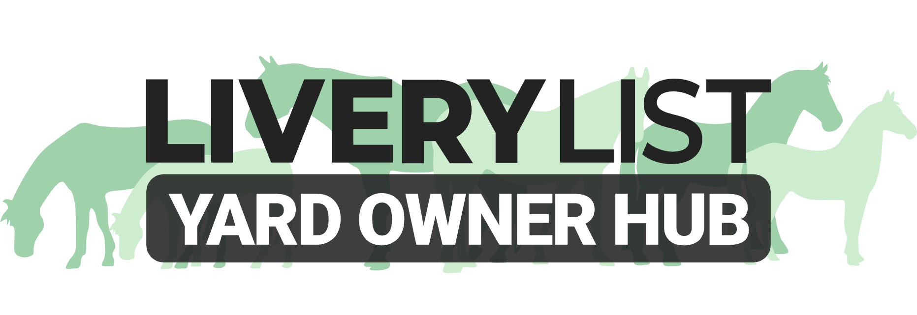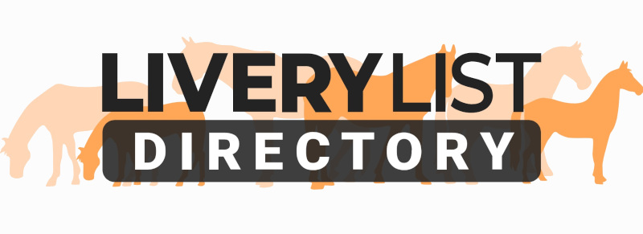

Template Third Service Provider Record and Disclaimer Form

The document below is a template form for yard owners who have persons visiting their yard to carry out professional services on their premises (ie freelance groom, farrier, EDT, instructor). To clarify, THIS FORM IS FOR THOSE OFFERING PROFESSIONAL, PAID SERVICES

As well as completion of this form, it is advised to ensure you see in person a copy of the claimed insurance policy, and ensure this covers adequately for services carried out in the course of business (ie not private rider insurance or BHS Gold). A copy of such insurance should be requested and retained.

It is recommended to ensure this form is updated annually, or upon expiry of the insurance policy date. Only ONE form need to be retained per service provider, regardless of the number of clients they may provide this service to.

THIRD PARTY SERVICE PROVIDER RECORD FORM
Service Provider Name:
Nature of Service:
Registration Number (where applicable):
Registered Address:
Telephone:
Telephone 2:
Email:

I hereby enter into this agreement in consideration of my ability and permission to carry out professional services at (Enter Name of Yard)
- By signing this form, I hereby acknowledge and confirm the following for each visit undertaken at the premises:
- that I have familiarised myself with any horse I shall be riding or handling in the course of this business
- that I am competent in the activities I plan to undertake whilst riding or handling the horse and that I am fit and able to participate in these activities without restriction or limitation
- that I am familiar and competent in the use of the associated tack and equipment, and that any equipment provided by myself is suitably maintained and correctly operated (including PAT testing for electrical equipment)
- that I am wearing suitable clothing, footwear and protective gear for the activities I plan to undertake
- have suitably assessed and familiarised myself with the facilities I shall be using
- that I shall follow instructions from the horse owner and/ or yard owner as necessary, and only permitted in areas as specified
- I confirm that I hold a current and valid insurance policy that covers me to carry out the services provided on a professional basis, and in receipt of remuneration:
Insurer Name;
Policy Number:
Date of Expiry:
Insurer Address:
Insurer Contact Number:
I confirm that I have provided a copy of this current insurance policy in full to the Yard Owner, ad understand that this will be kept on file in a GDPR compliant manner. I also agree that, if applicable, a new version of this shall be provided upon renewal.
3. I recognise the inherent risks involved in riding and handling horses, including but not limited to bites, kicks, abrasions, injuries from falls, slips and trips and allergic reactions.
4. The proprietor reserves the right to request that service providers or any other person using the facilities or accompanying clients do leave in circumstances where in the opinion of the proprietor and/or its management, a person is creating a dangerous situation, riding in a dangerous manner and/or where a person is mistreating a horse or acting irresponsibly. Where a person is asked to leave they must immediately return to their mode of transport and remove themselves from the premises.

5. All clients, and any person accompanying them, must act in accordance with the current UK Government guidance regarding their use of the facilities, including (but not limited to) regular sanitisation, ensuring that no one within their group has any COVID-19 symptoms, and maintaining social distancing at all times while at the premises.

6. Save for death or personal injury caused by negligence, (Enter Name Yard) nor its owners or employees does not accept any liability for any accident, loss, damage, injury or illness to hirers, riders, horses, owners, spectators, property, vehicles and their contents and accessories or any other person or property whatsoever, whether caused by their negligence, breach of contract or in any other way whatsoever during their attendance at the premises in connection with the usage of any of the equestrian facilities. Riding, working with horses and handling horses can be dangerous and horses may be unpredictable. Persons using the facilities do so at their own risk and the proprietor will not be held responsible for any accident, injury or loss.

READ THIS AGREEMENT CAREFULLY BEFORE SIGNING IT. YOUR SIGNATURE INDICATES YOUR UNDERSTANDING OF AND AGREEMENT TO ITS TERMS.
Name:
Date:
Participant’s Signature:
IMPORTANT
This information as provided above is intended to provide guidance and areas for consideration for those intending to enter into such arrangements. Anyone proposing to enter into such a written agreement should take consideration and their own legal advice as to their particular circumstances.
© LiveryList 2023

