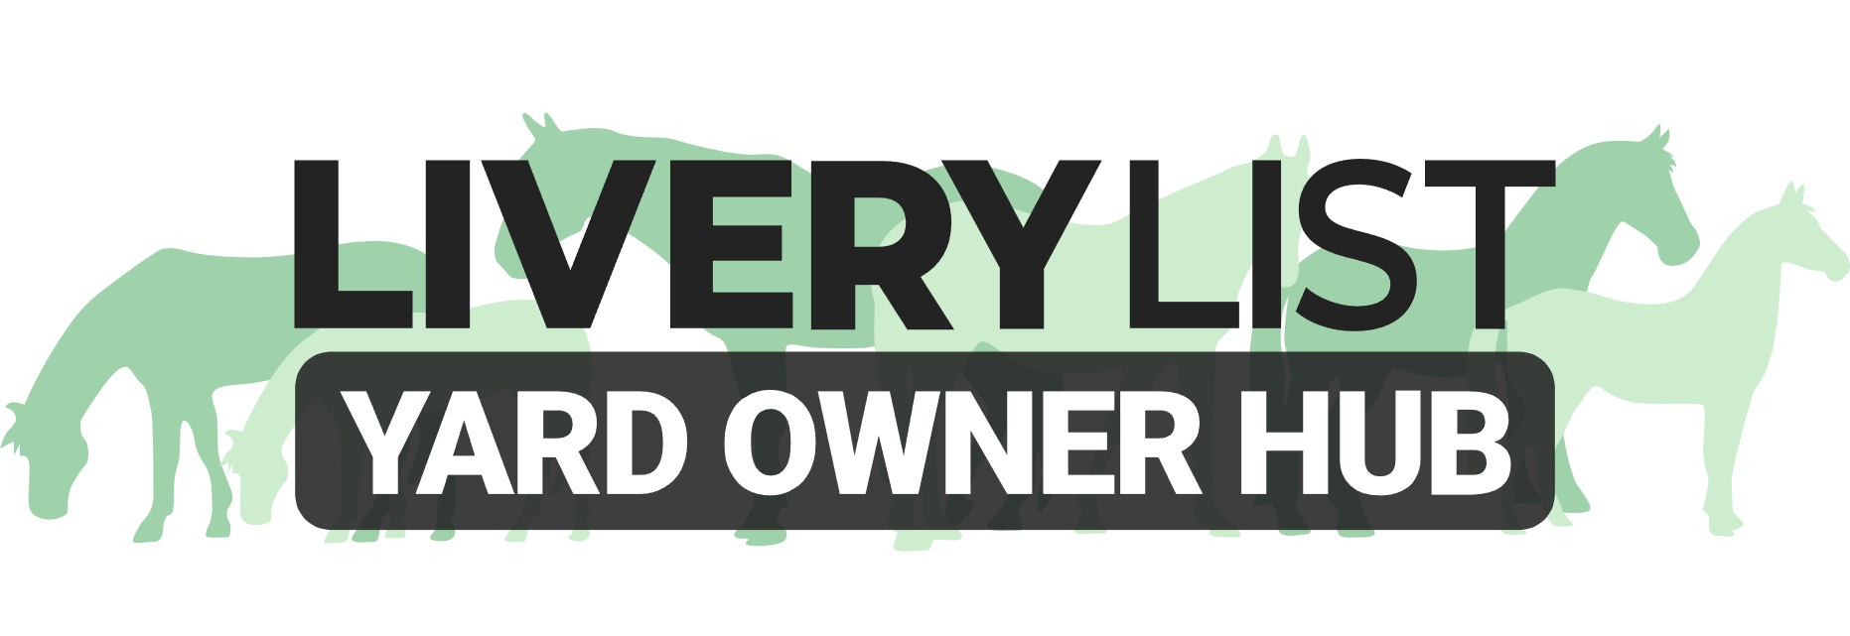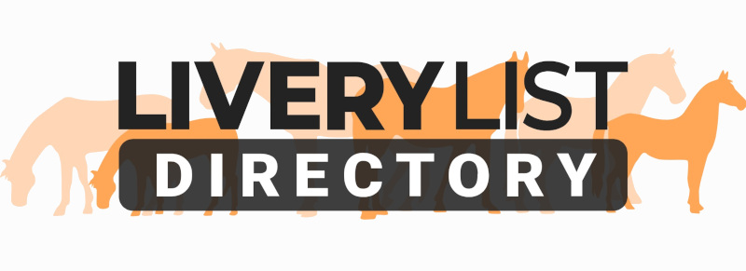
Template Welcome and Document Request Letter
The template letter below is an example of the type of letter that can be issued to new livery clients. This reminds both yard owner and horse owner of the necessary documents required for proper administration of clients and their horses during their livery period.
Ideally this, and the necessary copies of livery contract and other documentations, should be issued before arrival so that the horse owner can provide the necessary documents upon arrival. For those that choose to issue them upon arrival, you should stipulate a firm time frame in which these documents must be returned.

[ENTER YOUR BUSINESS NAME AND ADDRESS and/or LOGO]
[ENTER CLIENTS NAME AND ADDRESS]
[ENTER DATE]
Reference: New Livery Arrival Documents [AMEND AS NECESSARY]
Dear [ENTER CLIENTS NAME],
Welcome to [ENTER YARD NAME]. To facilitate good record keeping for all our clients, we remind new arrivals that we require to see and/ or receive the following documents upon arrival:
[AMEND FOLLOWING LIST AS NECESSARY]
✔ Signed Livery Agreement
✔ Security Deposit to the sum of £ [ENTER AMOUNT]
✔ First Months Livery in advance to the sum of £ [ENTER AMOUNT]
✔ Horse Passport (required legally to be retained on the yard for all packages over and above DIY)
✔ Proof of Vaccinations
✔ Copy of Strangles Blood Test
✔ Completed Horse Details Form
✔ Copy of Horse Insurance Policy (showing minimum Third-Party Liability)
✔ Copy of Owner ID and Proof of Address
As per our agreed Livery Contract which came into effect on [ENTER START DATE OF LIVERY CONTRACT], these documents are required on, or prior to, arrival at the yard. At the very latest, these documents must be received within 7 days of arrival. Failure to do so may be deemed as breach of contract.
These requirements are in place to help us facilitate good business management and ensure the safety and welfare of all equines, clients and staff on the yard.
The provision of these documents’ forms part of the terms of our livery services. Failure to provide these documents can result in immediate notice being given [OR AMEND AS NECESSARY]
If you have any issues or delays with providing these documents, please advise at the earliest opportunity.
Yours Sincerely,

[ENTER YOUR NAME, BUSINESS NAME AND POSITION]

IMPORTANT
This information as provided above is intended to provide guidance and areas for consideration for those intending to enter into such arrangements. Anyone proposing to enter into such a written agreement should take consideration and their own legal advice as to their particular circumstances.
© Livery List 2023

