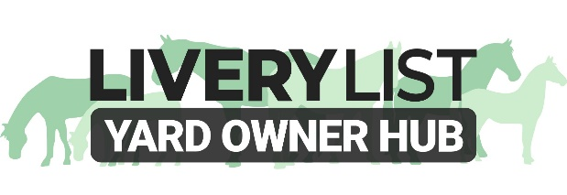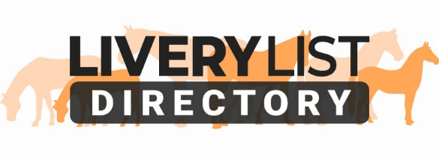
TEMPLATE RISK ASSESSMENT
Risk Assessments help you identify and reduce the risks on your yard that may cause injury or loss to yourself, staff, clients, visitors or equines. All businesses should have a Risk Assessment as part of the compliance for their insurance policy and is also beneficial in the event of accidents to show precautions and preventative steps that have been taken.
The below document is an example only and not exhaustive in its content. It is important that this assessment is suitable for your own premises, and that you undertake the necessary advice and guidance prior to completion of the assessment, according to your own yard layout and situation. It is advisable to seek the assistance of a dedicated Health and Safety Advisor or Assessor to ensure that correct documentation is made. It is also advisable to have a separate Fire or Emergency Plan.

RISK ASSESSMENT- (INSERT DATE OF MOST RECENT UPDATE)
(INSERT YARD NAME AND ADDRESS)

The original Risk assessment was carried out in (INSERT DATE).
All risk assessments are carried out by (INSERT NAME AND POSITION)
All new staff, work experience students, volunteers, visitors and livery clients should be taken through the risk assessment on arrival.
All staff should give training to riding school clients where applicable.
Reassessments are carried out periodically.
Bimonthly H&S meetings held with staff.
ALL should sign a document to confirm they have read the risk assessments.
Various actions have been taken and added through the years as this is a working document.
(INSERT NAME) has been appointed the advisor on all H&S issues for (INSERT YARD NAME)

RISK ASSESSMENT- (INSERT DATE OF MOST RECENT UPDATE)
(INSERT YARD NAME AND ADDRESS)

Hazard | Who May Be Harmed and How? | Preventative Steps in Place | Preventative Steps to Implement | Action by Whom? | Action Date | Status
General Yard Tasks:  Lifting & carrying hay, shavings, feed sacks, saddles, feed and water buckets. Sweeping yard, mucking out, bedding down, maintaining muck heap | Staff and Clients  - Injury to lower back  - Falling bales Dust  - Stab injury from fork  - Dust Inhalation  - Handling horses | - Minimising distance and amount moved  - Correct instruction, training and supervision by skilled staff,  - Using appropriate handling aids and protective equipment : trolleys, wheelbarrows , gloves, masks etc  - Ensure sufficient people available on delivery days.  - Large bales only moved by contractor  - Daily inspection of tools by staff prior to use to check they are fit for use.  - Rubber mats in all stables. | - Poster on lifting to be displayed on staff notice board  - Make a note of all staffs last tetanus injections
Leading and Handling Horses:  Catching / turn out Leading clients  Lunging and Loading  Grooming,  Tacking Up | Staff and Clients  - Blistering or Friction burns to hands  - Tread injuries to feet  - Bites from horse  - Kick injuries | - Correct instruction, training and supervision. regarding methods of restraint and safe handling as well as positioning of handler, horse behavior and suitable restraining equipment.  - Night time loading. Lights in car park to be switched on.  - Maximum of two horses to be led to /from field.  - Obligatory for staff to wear hat/ gloves.  - Restricted access to stables for children (signs displayed)  - Only specific trained staff to handle stallions  - Gates to turn out areas must be also secured with a rope  - Suitable and safe tie up areas with enough working space | - Reminders at Bimonthly  - Supervision/training new staff / students.
CONTINUE TO COMPLETE IN THIS MANNER…

Other aspects to consider:
- Riding (safe use of arena, hats, safe equipment, etc)
- Coaching and Instruction (Correct training, safe equipment, etc)
- Hacking Out (Hi-Viz and hats, suitable training, clear access out of yard driveway etc)
- Arena and Yard Maintenance Tasks (building courses, driving machinery, correct storage)
- Veterinary Treatment (worming, hosing off, applying medication or vaccinations, safe use of medicines etc)
- Electrical Items (tearoom, clipping, lights, electrical safety, power outlets, PAT testing equipment etc)
- Storage Areas (safe storage of bales, tidy areas, minimal equipment, dedicated tool storage etc)
- General Moving About Premises (Slips and trips, security, restricted areas, correct footwear/ clothing, putting things away etc)
- Personal hygiene (washing hands, dedicated eating areas, notification of illness etc)
- Seasonal Hazards (suncream, ice, frozen pipes, cleaning drainage areas, reducing dust in arenas etc)
- Using Equipment ie tractor (Safe training, check vehicle before use, only in certain areas, regularly maintained etc)
- Fire Safety (training, extinguishers, dedicated Fire/ Emergency Procedure, fire inspection and tests etc)
- Third Party Visitors (service providers- farriers, grooms, family and friends, children, people hiring facilities etc)
- Events on site (Clinics training, lessons, events, parking, visitor protocol)

You can also include at the bottom of your risk assessment the clear guidance, rules or conditions for particular activities on the yard for staff and clients, or you can provide a separate Yard Handbook to cover these aspects and have acceptance of this as a clause within your Livery Contract.

© LiveryList 2025

