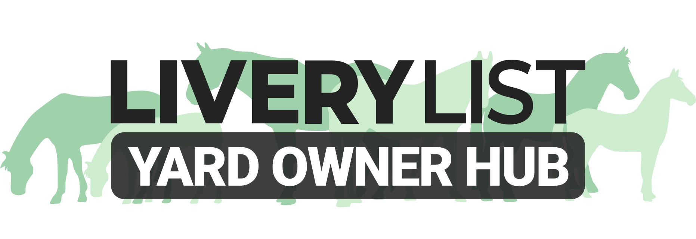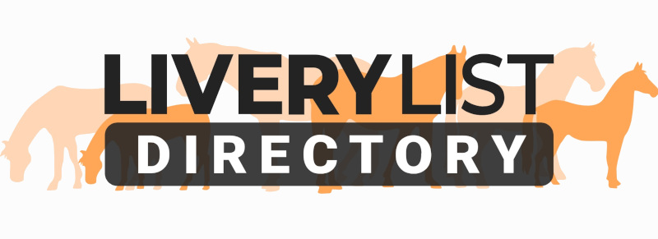
Template Passport Retention Form
Following the introduction of the Equine Identification Regulations 2018, it is now a legal requirement for equines on any more than a basic DIY Livery package to be accompanied by their Equine Passport at all times, including when stabled or at grass. This, therefore, makes it a requirement for the Equine Passport to be retained at the premises housing that equine, such as a livery yard, and deems the yard owner as the ‘Keeper’ of the animal. Such storage should be GDPR compliant and ensure the safe retention and restricted access of all Equine Passports at all times, but ensuring access to the horse owner as required.

It is also the responsibility of a Livery Yard owner to ensure all equines kept on their premises hold a valid Equine Passport and as such all Passports should be checked prior to acceptance and arrival of new equines to the yard.

Upon receipt of a client’s Horse Passport/s, you should issue them with a copy of the form below confirming retention. A copy of this should be also kept for your records. A form is required for each individual horse for which it applies.

This form DOES NOT apply if the owner effuses to give the yard owner the passport. In which case, a Retention Disclaimer form should be completed. This is available on the LYO HUB.

Passport Retention Disclaimer Form
(Enter Yard Name)

Following the introduction of the Equine Identification (England) Regulations 2018, it is now a legal requirement for equines to be accompanied by their Equine Passport at all times, including when stabled or at grass. This, therefore, makes it a requirement for the Equine Passport to be retained at the premises housing that equine. This document confirms that I, as the owner of the equine detailed below, am refusing to leave my passport in the custody of the keeper, as detailed below.

The following details should be copied directly from the Equine Passport:

Registered Name of Equine …………………………………………………………………………..
Passport Issuing Authority (PIO): …………………………………………………………………………..
Unique Equine Life Number: …………………………………………………………………………..
Microchip/ Transponder Code: …………………………………………………………………………..

Registered Owner: …………………………………………………………………………..
Registered Owner Address: …………………………………………………………………………..
…………………………………………………………………………..
…………………………………………………………………………..
…………………………………………………………………………..

Details of the Premises where the equine is kept:

Name of Premises: …………………………………………………………………………..
Person Responsible: …………………………………………………………………………..
Address of Premises: …………………………………………………………………………..
…………………………………………………………………………..
…………………………………………………………………………..
…………………………………………………………………………..

Date of Arrival of Equine at Premises: …………………………………………………………………………..

HORSE OWNER DECLARATION: By signing this form, I confirm I have been made aware of the new passporting regulations and have provided the yard owner with the passport as required. I am of the understanding that this is to be stored safely and securely, with the necessary access provided if the horse is transported or attended by a veterinary surgeon, and shall be returned upon my termination of livery contract and removal of the horse from the yard at such time.

Signed:

Print Name:

Date:

YARD OWNER DECLARATION: By signing this form, I confirm that I have received the Horse Passport. I am of the understanding that this is to be stored safely and securely, with the necessary access provided if the horse is transported or attended by a veterinary surgeon, and shall be returned to the owner upon termination of livery contract and removal of the horse from the yard at such time.

Signed:

Print Name:

Date:

IMPORTANT
This information as provided above is intended to provide guidance and areas for consideration for those intending to enter into such arrangements. Anyone proposing to enter into such a written agreement should take consideration and their own legal advice as to their particular circumstances.

© Livery List 2023

