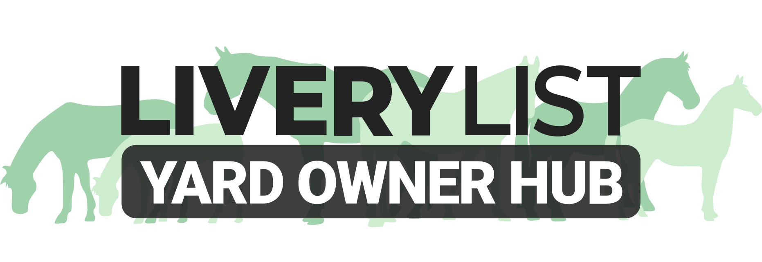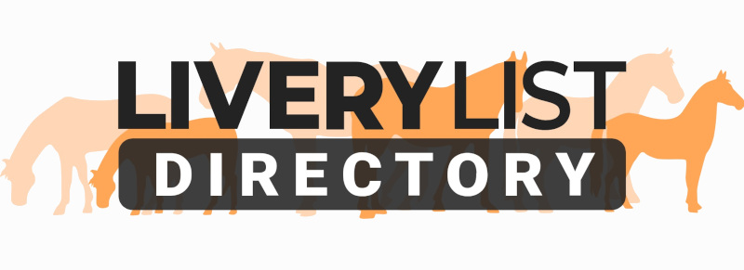
Template Passport Retention Disclaimer Form
Following the introduction of the Equine Identification Regulations 2018, it is now a legal requirement for equines on any more than a basic DIY Livery package to be accompanied by their Equine Passport at all times, including when stabled or at grass. This, therefore, makes it a requirement for the Equine Passport to be retained at the premises housing that equine, such as a livery yard, and deems the yard owner as the ‘Keeper’ of the animal. Such storage should be GDPR compliant and ensure the safe retention and restricted access of all Equine Passports at all times, but ensuring access to the horse owner as required.

It is also the responsibility of a Livery Yard owner to ensure all equines kept on their premises hold a valid Equine Passport and as such all Passports should be checked prior to acceptance and arrival of new equines to the yard.

In certain circumstances, despite it being a legal requirement, clients may refuse for their Equine Passport to be left on the premises. In such cases, they should be made aware that by refusing as such, they are breaking the law and putting both themselves, as the horse owner, and the owner of the premises, as keeper, at risk of civil or criminal proceedings for failure to adhere to the new legislation. Effectively those refusing to leave their passport on the premises are breaking the law, not just yard rules.

In the event that a yard owner is willing to accept an owners refusal to leave the passport, below is a template disclaimer for such owners to sign. This should not be offered as an alternative to passport retention, but as a last resort. Whilst this is no legal substitute for possessing the passport, in the event of an inspection and failure to produce documentation, it shall at least show due diligence to inspectors in an effort to adhere to the new legislation.

This should be retained with a colour copy of the Cover, ID and Vaccination pages of the passport. These forms should be amended as necessary and completed upon arrival of a new livery. A Disclaimer form is required for each individual horse for which it applies. A copy of the disclaimer should be retained by both parties.

Passport Retention Disclaimer Form

Following the introduction of the Equine Identification (England) Regulations 2018, it is now a legal requirement for equines to be accompanied by their Equine Passport at all times, including when stabled or at grass. This, therefore, makes it a requirement for the Equine Passport to be retained at the premises housing that equine. This document confirms that I, as the owner of the equine detailed below, am refusing to leave my passport in the custody of the keeper, as detailed below.

The following details should be copied directly from the Equine Passport:

Registered Name of Equine …………………………………………………………………………..
Passport Issuing Authority (PIO): …………………………………………………………………………..
Unique Equine Life Number: …………………………………………………………………………..
Microchip/ Transponder Code: …………………………………………………………………………..

Registered Owner: …………………………………………………………………………..
Registered Owner Address: …………………………………………………………………………..
…………………………………………………………………………..
…………………………………………………………………………..
…………………………………………………………………………..

Details of the Premises where the equine is kept:

Name of Premises: …………………………………………………………………………..
Person Responsible: …………………………………………………………………………..
Address of Premises: …………………………………………………………………………..
…………………………………………………………………………..
…………………………………………………………………………..
…………………………………………………………………………..

Date of Arrival of Equine at Premises: …………………………………………………………………………..

By signing this form, I confirm I have been made aware of the new legislation and the requirement of the retention of the Equine Passport at the above premises in order to be able to immediately prove identification of the horse in the event of an inspection by DEFRA, welfare inspector or another appointed inspector. I can confirm that the above-named person responsible has requested retention of my Equine Passport on the premises on the grounds of this legislation.

By signing this form, I confirm that despite the clarification of the legislation and request of the passport from the yard owner, I refuse to abide by this legislation and do not permit retention of the Equine Passport at the premises. I also agree that I am aware that failure to abide by this legislation may put myself, as horse owner, and the above-mentioned person responsible, as the keeper, at risk of criminal or civil proceedings for non-compliance.

Horse Owner: Responsible Person:

Signed: Signed:

Print Name: Print Name:

Date: Date:

IMPORTANT
This information as provided above is intended to provide guidance and areas for consideration for those intending to enter into such arrangements. Anyone proposing to enter into such a written agreement should take consideration and their own legal advice as to their particular circumstances.

© Livery List 2023

