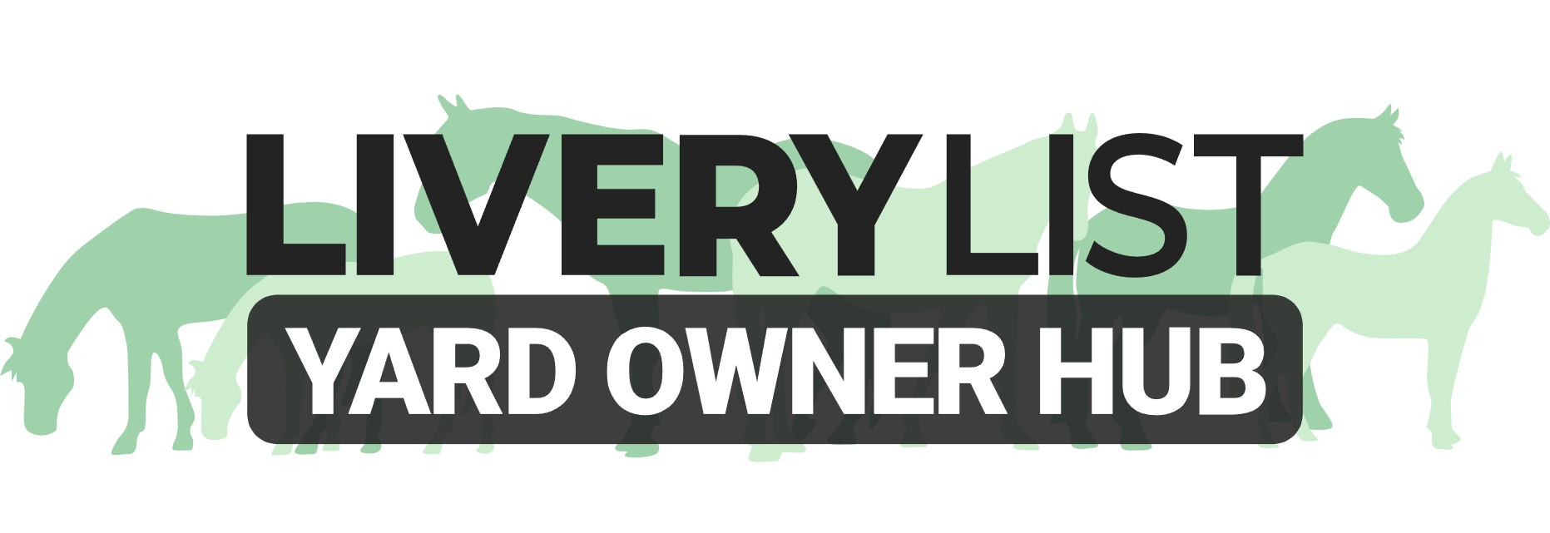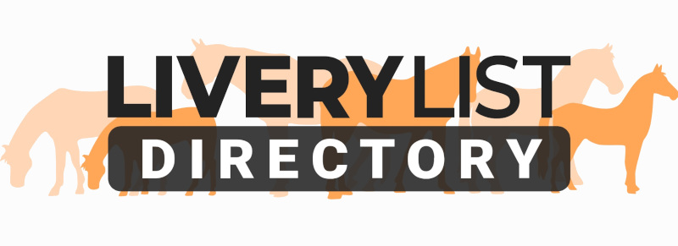
Sample Notice Letter
This template letter is designed as a basic outline for a livery yard to present their client in the event of serving notice and terminating their livery agreement.

This is a guide only and the changes to the agreement should be edited to reflect the specific circumstances or clauses in your livery contract with regards to notice periods, return of deposits and suchlike. Regardless of a livery contract, a standard notice period would usually be 30 days, 4 weeks or one calendar month depending upon your terms of payment. You can serve immediate notice or shorter term notice in the event of extenuating circumstances or gross misconduct.

Amendments can be added or removed as appropriate to make the notice as concise or simple as required. There is no necessity to include reasons for serving notice unless specifically wishing to. It is important, however, to clarify items of closure before they may depart the yard if not included in your livery agreement, or in the absence of a livery agreement. The items highlighted in bold indicate common areas to be personalised.

[ENTER YOUR BUSINESS NAME AND ADDRESS]
[ENTER CLIENTS NAME AND ADDRESS]
[ENTER DATE]
Reference: Termination of Livery Contract [AMEND AS NECESSARY]
Dear [ENTER LIVERY CLIENTS NAME],

I am writing to advise of/ confirm [AMEND AS NECESSARY] the termination of your livery contract at [ENTER YARD NAME].

As per the terms of our livery contract, there is a 30-day notice period. After this period has lapsed, all rights associated with your livery contract are terminated in full. You must therefore arrange to have departed the yard, including removal of all equines, belongings and equipment, no later than 5pm on 00th January 2020 [AMEND AS NECESSARY].

Prior to departure, all monies owed to the date of departure- including any livery fees and service reimbursements- must be made in full. A statement of account can be provided upon request [AMEND AS NECESSARY].

Upon satisfactory termination of the agreement, any security deposits will be returned within 7 days [AMEND AS NECESSARY]

Yours Sincerely,
[SIGN, ENTER YOUR NAME, BUSINESS NAME AND POSITION]

IMPORTANT
This information as provided above is intended to provide guidance and areas for consideration for those intending to enter into such arrangements. Anyone proposing to enter into such a written agreement should take consideration and their own legal advice as to their particular circumstances.

© Livery List 2023

