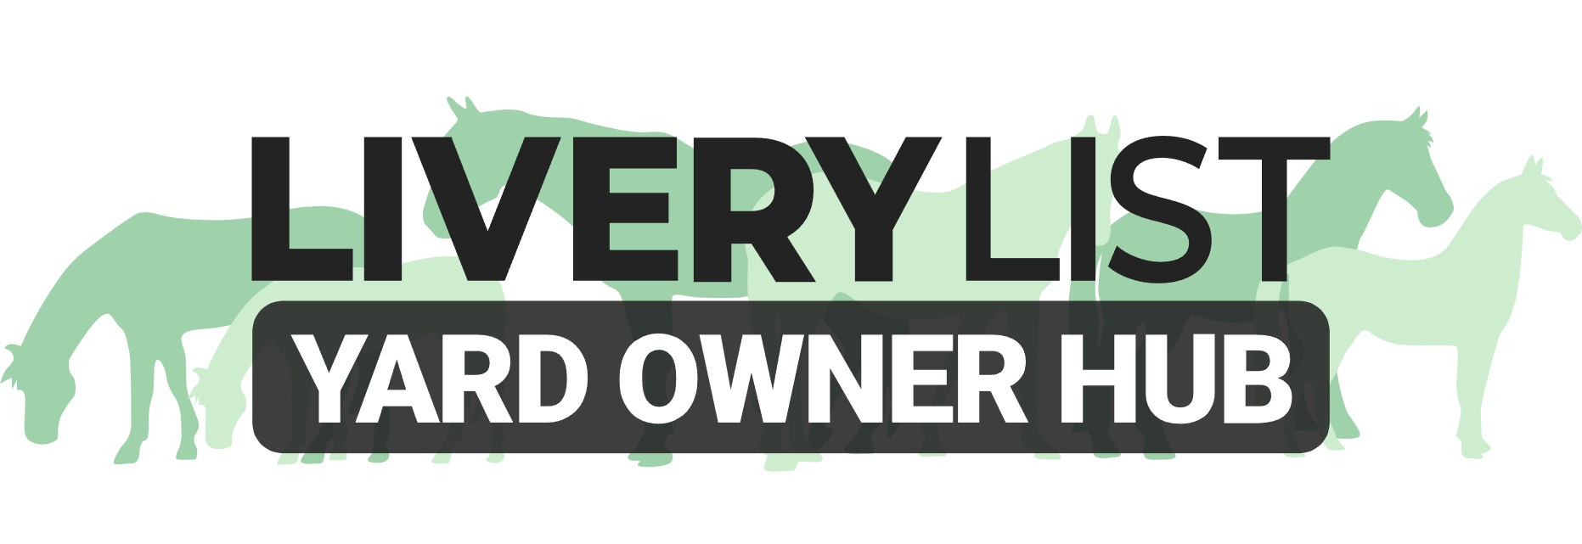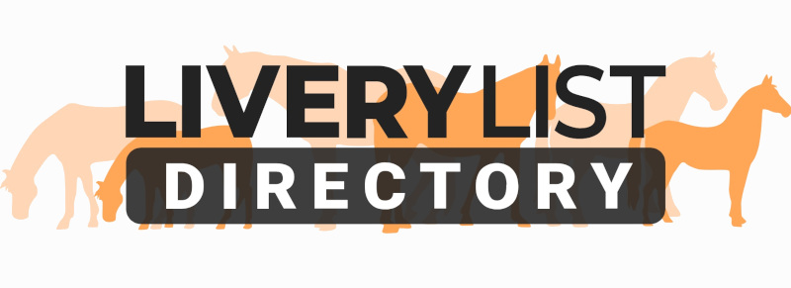
Template Horse and Owner Details Form
The template form below is a guide for yard owners and horse owners as to the type of form you could complete in order to ensure that all parties are fully informed as to the details of liveries on their premises. The level of information required will depend upon the livery package and level of care and responsibility therein. It is also advised to have detailed information on livery clients for both debt recovery and emergency situations.

These forms should be completed upon arrival and stored securely, yet accessibly on the yard to be referred to as and when necessary by the relevant people. They should be kept up to date at all times. For livery packages requiring an end of life plan for equines, it is advised that one of these be also completed to the owners wishes.

This form is in no way a livery agreement, just a source of information for parties involved.

LIVERY DETAILS FORM

Horse Name ……………………………………

OWNER DETAILS

Name ……………………………………………………………………………………….
Home Address ……………………………………………………………………………………….
……………………………………………………………………………………….
……………………………………………………………………………………….
……………………………………………………………………………………….

Contact- Home ……………………………………………………………………………………….
Contact- Mobile ……………………………………………………………………………………….
Contact- Work ……………………………………………………………………………………….

Email Address ……………………………………………………………………………………….

Next of Kin ……………………………………………………………………………………….
Contact ……………………………………………………………………………………….
Relationship ……………………………………………………………………………………….

Next of Kin ……………………………………………………………………………………….
Contact ……………………………………………………………………………………….
Relationship ……………………………………………………………………………………….

Medical Issues, Medication or Allergies of OWNER -in the event of an emergency or accident on the yard
…………………………………………………………………………………………….…………………………………………………….……………………………………………………….…………………………………….…………………………………………………………………………………………………………….…………………………………….……………………………………………………………………………………………………………..……………
……….…………………………………….……………………………………………………………………………………………………………..……………

Any other relevant information we should be aware of for the OWNER (or regular visitors to the yard)?
…………………………………………………………………………………………….…………………………………………………….……………………………………………………….…………………………………….…………………………………………………………………………………………………………….…………………………………….……………………………………………………………………………………………………………..……………
……….…………………………………….……………………………………………………………………………………………………………..……………

HORSE DETAILS
Stable Name ……………………………………………………………………………………….

Age/ D.O.B ……………………………………………………………………………………….
Breed ……………………………………………………………………………………….
Size ……………………………………………………………………………………….
Colour ……………………………………………………………………………………….
Identifying Markings ……………………………………………………………………………………….
……………………………………………………………………………………….

Registered Name ……………………………………………………………………………………….
Passport Authority ……………………………………………………………………………………….
Unique ID Number ……………………………………………………………………………………….

Does the horse have any INJURIES OR ILLNESSES that the yard should be aware of?
…………………………………………………………………………………………….…………………………………………………….……………………………………………………….…………………………………….…………………………………………………………………………………………………………….…………………………………….……………………………………………………………………………………………………………..……………
……….…………………………………….……………………………………………………………………………………………………………..……………

Does the horse have any ALLERGIES OR DIETARY REQUIREMENTS that the yard should be aware of?
…………………………………………………………………………………………….…………………………………………………….……………………………………………………….…………………………………….…………………………………………………………………………………………………………….…………………………………….……………………………………………………………………………………………………………..……………
……….…………………………………….……………………………………………………………………………………………………………..……………

Does the horse have any VICES OR BEHAVIOURHAL ISSUES that the yard should be aware of?
…………………………………………………………………………………………….…………………………………………………….……………………………………………………….…………………………………….…………………………………………………………………………………………………………….…………………………………….……………………………………………………………………………………………………………..……………
……….…………………………………….……………………………………………………………………………………………………………..……………

Insurer ……………………………………………………………………………………….
Policy Number ……………………………………………………………………………………….
Renewal Date ……………………………………………………………………………………….

Preferred Vet ……………………………………………………………………………………….
Contact ……………………………………………………………………………………….
Emergency Number ……………………………………………………………………………………….

Preferred Farrier ……………………………………………………………………………………….
Contact ……………………………………………………………………………………….

Instructor/ Trainer ……………………………………………………………………………………….
Contact ……………………………………………………………………………………….

Any other relevant information we should be aware of for the HORSE?
…………………………………………………………………………………………….…………………………………………………….……………………………………………………….…………………………………….…………………………………………………………………………………………………………….…………………………………….……………………………………………………………………………………………………………..……………
……….…………………………………….……………………………………………………………………………………………………………..……………

In the event of the owner’s death, illness or prolonged incapacity to care for the horse, please advise on a ‘next of kin’ or secondary responsible person who shall become responsible for decisions relating to the animal in lieu of the owner:

Name ……………………………………………………………………………………….
Contact ……………………………………………………………………………………….
Relationship ……………………………………………………………………………………….

Please ensure that all your horse’s belongings are clearly marked, including feed and water buckets. Please ensure that a schedule of your horses feed and hay requirements are clearly on display in the feed room and all storage bins labelled clearly.

Please provide in return with this form the following documents;
- Horse Passport
- Copy of Horse Passport ID page
- Copy of Horse Vaccinations
- Copy of Utility Bill
- Copy of Horse Insurance Certificate

IMPORTANT
This information as provided above is intended to provide guidance and areas for consideration for those intending to enter into such arrangements. Anyone proposing to enter into such a written agreement should take consideration and their own legal advice as to their particular circumstances.

© Livery List 2023

