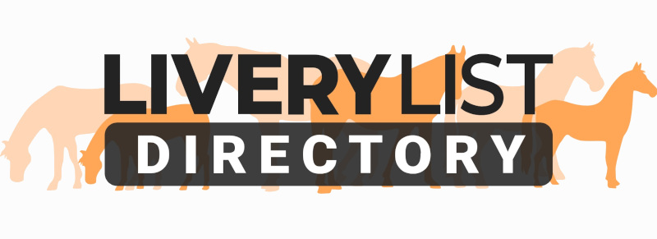
Template Letter of Intent- Debt Action
The template letter below is a guide as to the type of document you can provide when a Livery Client owns monies of any amount.

This is a guide only and the changes to the letter should be edited to reflect the specific circumstances. Amendments can be added or removed as appropriate to make the letter as concise or simple as required. The items highlighted in bold indicate common areas to be personalised.

It is recommended that any such letters are sent via recorded delivery to the debtors home address, along with the appendixes detailed at the end of the template, and records kept of any responses in the event that court action is undertaken.

[ENTER YOUR BUSINESS NAME AND ADDRESS]
[ENTER DEBTORS NAME AND ADDRESS]
[ENTER DATE]
Reference: Notice of Intention for Debt Recovery [AMEND AS NECESSARY]
Dear [ENTER DEBTORS NAME],
Due to outstanding debts to the sum of [ENTER OUTSTANDING AMOUNT] for unpaid livery fees [OR AMEND AS NECESSARY] I am writing to inform you of the intention to apply for a County Court Judgement (CCJ) in order to recoup these monies. Please find attached a statement of the monies owed for your reference [ATTACH STATEMENT OF ACCOUNT].
As per our agreed Livery Contract which came into effect on [ENTER START DATE OF LIVERY CONTRACT], copy attached [ATTACH A COPY OF YOUR LIVERY CONTRACT IF YOU HAVE ONE OR DELETE AS NECESSARY], these monies are now overdue despite previous reminders and as such you have broken the payment terms of our contract.
Please be advised that if a CCJ is successfully applied for, you will be liable not only for the outstanding amount, but also for a standard 8% rate of interest on all monies owed to the day of payment plus any associated costs I have incurred in my attempts to reclaim the debt.
In addition, please be advised that a CCJ is a very serious matter. Once applied for, a CCJ will remain on your credit file for 6 years and could potentially affect your future ability to obtain financial lending, mortgages, bank accounts, overdrafts, property rental, insurances and other associated restrictions.
I have contacted you numerous times to resolve the matter and for you to settle the outstanding debt but as yet it still remain unpaid [OR AMEND AS NEECSSARY]. I would therefore urge you to contact me to resolve the matter amicably and make payment at your earliest opportunity.
These letter of intent is in line with the necessary 'Pre-Action Protocol' for notifying you of my intention to take the claim to court. If no payment or response is received from you within 28 days of the delivery date of this letter you leave me no option but to apply to the County Court Money Claims Centre to begin proceedings.
Yours Sincerely,

[ENTER YOUR NAME, BUSINESS NAME AND POSITION]

[ATTACH:
- COPY OF LIVERY CONTRACT
- STATEMENT OF ACCOUNT (AMOUNTS, WHAT FEES ARE FOR, WHEN THEY WERE DUE)
SEND LETTER AND DOCUMENTS VIA FIRST CLASS RECORDED DELIVERY]
IMPORTANT
This information as provided above is intended to provide guidance and areas for consideration for those intending to enter into such arrangements. Anyone proposing to enter into such a written agreement should take consideration and their own legal advice as to their particular circumstances.

© Livery List 2023

