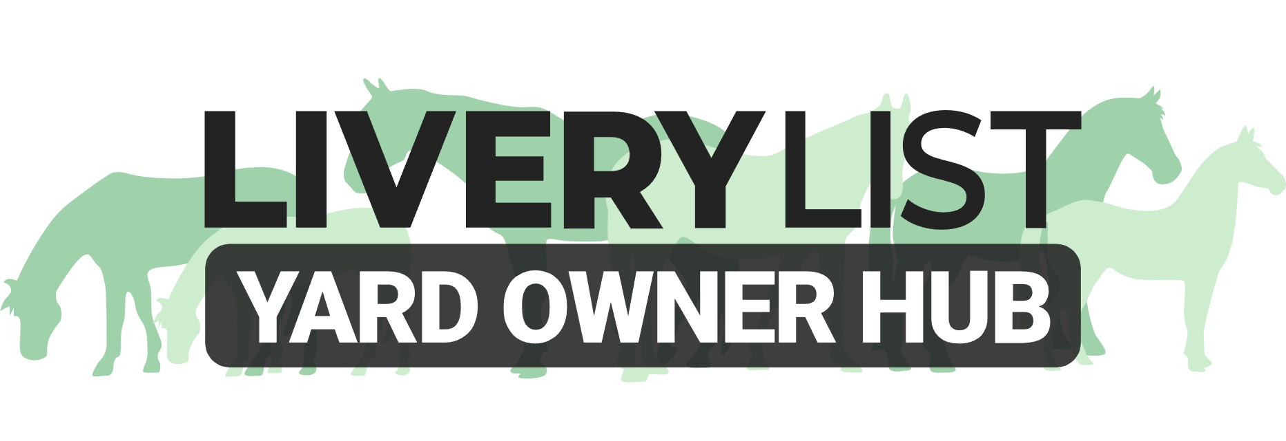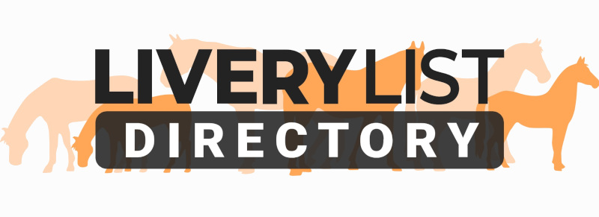
Template General Data Protection Regulation (GDPR) Notice
The information below is a guide for yard owners and horse owners as they type of form you could provide to clients in order to ensure that all parties are fully informed as to the use of any personal details that may be stored by yards on their clients. This could be details forms of horses and owners, contact details, copies of horse passports or the use of CCTV on site.

These forms should be amended as necessary and completed upon arrival of a new livery. A copy should be retained by both parties.

EU General Data Protection Regulation (GDPR) Notice

The EU General Data protection Regulation (GDPR) came into force across the European Union (EU) on 25th May 2018 and brings with it significant changes to data protection law. The new regulation aims to standardise data protection lawns and processing across the EU.

(Enter Yard or Business Name Here) Is the Data Controller for your personal data, which means that we decide what information we need to keep about you, why and how we process that data.

- What personal information do we keep and process?
Before bringing your horse to (Enter Yard or Business Name Here), we ask you to complete a Horse/ Owner Information Pack (Or Amend as necessary) which asks for personal data. This should be updated and maintained for the duration of your contract with us. This data can only be viewed by relevant members of staff.

- What do we use your personal data for?
Personal data is used to help us best care for you and your horse. It will enable us to contact you and relevant professionals in relation to the care of the horse. It will also allow us to contact a next of kin on your behalf if necessary.

- How is your personal data stored?
Your personal data is stored in the following ways: password protected PC, password protected phone or mobile device, locked cabinet, accident records (Or Amend as necessary). We will not share your personal data with any other third party without your permission.

- What is the legal basis for processing your data?
Your personal data is processed based on your contract with us for the stabling of your horse and our responsibility over the care of your horse. It is deemed necessary to allow us to contact you or take the relevant action in the event of an emergency.

- How long do we keep your personal data for?
We keep your personal data for the duration of your contract with us.

- What are your rights with regards to your personal data?
- To know what personal data we keep about you
- Request a copy of the personal data we hold about you
- Request that we correct any personal data which is found to be inaccurate or out of date
- Request that we erase any personal data where it is no longer necessary for us to hold that data
- Withdraw your consent for processing to which you have previously given your consent.

By signing this form, you are confirming that you have read this Data protection Notice and that you are consenting to (Enter Yard or Business Name Here) holding and processing your personal data for the purposes listed above.

Name ……………………………………………………………….. Date ……………………………

Signed:

IMPORTANT
This information as provided above is intended to provide guidance and areas for consideration for those intending to enter into such arrangements. Anyone proposing to enter into such a written agreement should take consideration and their own legal advice as to their particular circumstances.

© Livery List 2023

