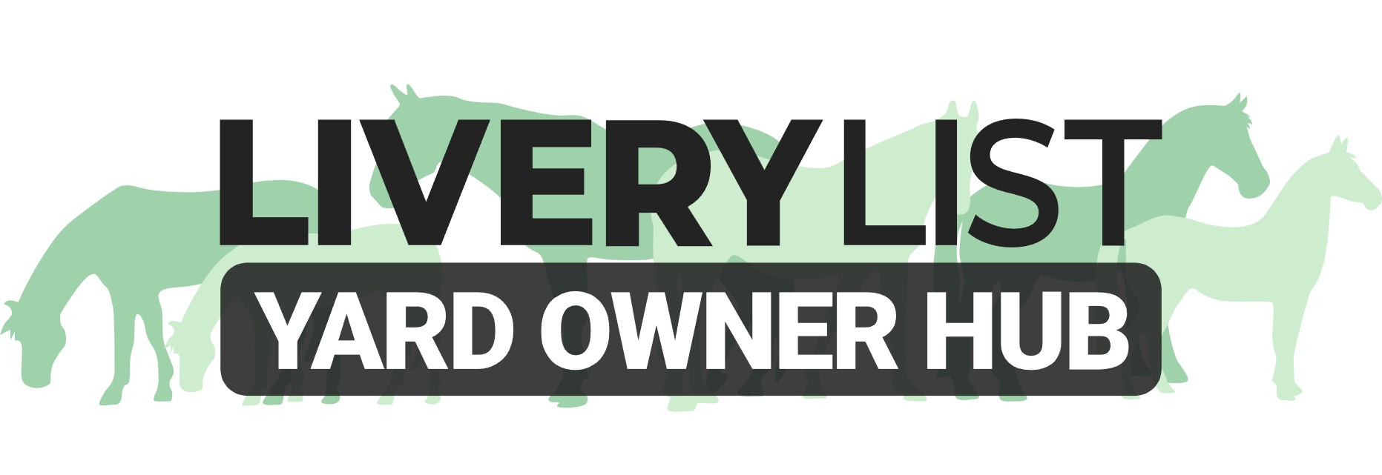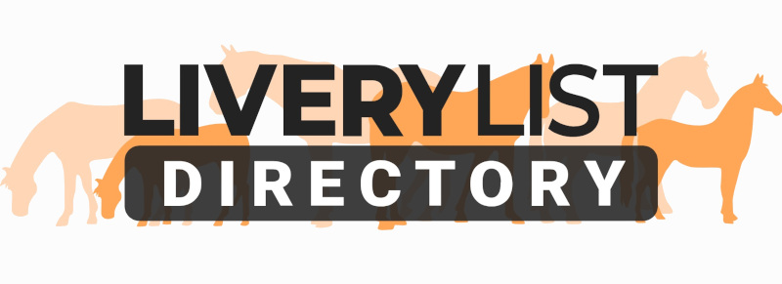
Template Exceptional Price Increase Letter

The document below is a template letter for yard owners to issue to their clients in respect of any unforeseen or additional increases to their livery or service charges. The expected notice period for any such charges would be a minimum of 30 days. It is recommended to include in your livery contract a clause permitting annual price increases or discretional price increases. Best practice is to increase livery charges annually or bi-annually in line with inflation and/ or your own supplier increases. However, in exceptional circumstances it may be necessary to increase your prices in addition to these planned changes or shortly after a preceding increase in order for your business to remain sustainable.

To help you calculate your livery charges, there is also a document ‘Livery Charges Calculation Sheet’ which will help you accurately work out your costs and make any changes to your price structure accordingly.

[ENTER YOUR BUSINESS NAME AND ADDRESS]
[ENTER CLIENTS NAME AND ADDRESS]
[ENTER DATE]
Reference: Notice of Price Increase
Dear [ENTER CLIENTS NAME],
Due to continued rising running and maintenance costs of the yard, we write to inform you that we have no option but to further increase our livery and service charges to reflect this. These changes will come into force on [ENTER START DATE].
Please find below our new prices: [AMEND AS NECESSARY]
Livery Packages:
DIY Livery - £30 per week [OPTIONAL TO DETAIL PRICE INCREASE AMOUNT PER WEEK/ MONTH]
Assisted DIY- £55 per week
Additional Services:
Full Day Cover - £12 per day [OPTIONAL TO DETAIL PRICE INCREASE AMOUNT PER SERVICE]
Turnout or Bring In - £3
We understand that finances are tight for all at the moment and issue this unavoidable price increase in good faith. We must issue this additional price increase to ensure we can continue maintaining and running the yard to the standards expected by our clients, and to enable us to continue offering the services and facilities you currently have access to.
If any clients see issue with the new charges, I urge you to speak to me directly at your earliest opportunity.
Kind regards,
[ENTER YOUR NAME, BUSINESS NAME AND POSITION]
IMPORTANT
This information as provided above is intended to provide guidance and areas for consideration for those intending to enter into such arrangements. Anyone proposing to enter into such a written agreement should take consideration and their own legal advice as to their particular circumstances.
© Livery List 2023

