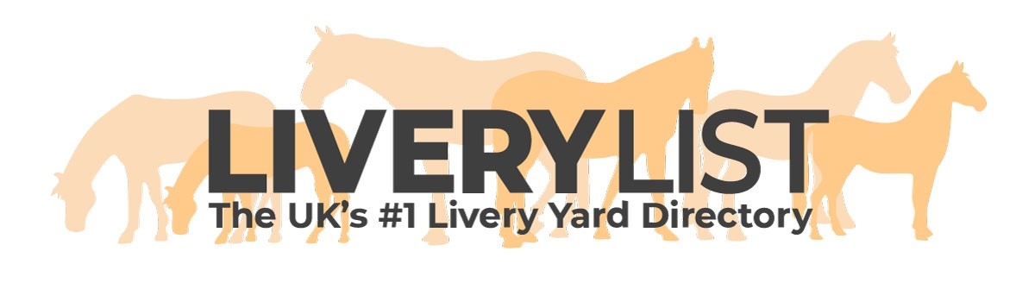
End of Life Options Template
The template form below is a guide for yard owners and horse owners as to the type of form you could complete in order to ensure that all parties are fully informed as to the wishes of an owner in the evEnt of death of an equine in your care. This is highly recommended, but not restricted to, those offering retirement livery. You must remember that accidents and illnesses can occur at any time. It is important, for swift action, to be aware of the owner’s choices in such circumstances.

These elements are recommended to be included as part of a retirement livery contract and can also be included on the appendix of any other long term livery agreement.

These forms should be completed upon arrival and stored securely, yet accessibly on the yard to be referred to as and when necessary by the relevant people.

This form is in no way a livery agreement, just a source of information for parties involved.

EQUINE END OF LIFE OPTIONS FORM

Horse Name ……………………………………

(The initial owner and horse details on this form can be omitted if contained on other documentation- such as a Livery Details Form- you just need to ensure that the equine and owner are clearly identified on this form)

OWNER DETAILS

Name ……………………………………………………………………………………….
Home Address ……………………………………………………………………………………….
……………………………………………………………………………………….
……………………………………………………………………………………….
……………………………………………………………………………………….

Contact- Home ……………………………………………………………………………………….
Contact- Mobile ……………………………………………………………………………………….
Contact- Work ……………………………………………………………………………………….

HORSE DETAILS
Stable Name ……………………………………………………………………………………….

Age/ D.O.B ……………………………………………………………………………………….
Breed ……………………………………………………………………………………….
Size ……………………………………………………………………………………….
Colour ……………………………………………………………………………………….
Identifying Markings ……………………………………………………………………………………….
……………………………………………………………………………………….

Registered Name ……………………………………………………………………………………….
Passport Authority ……………………………………………………………………………………….
Unique ID Number ……………………………………………………………………………………….

RESPONSIBLE PERSON

Please give details below of a secondary person who, in the event we are unable to contact the owner, is able to give instructions on behalf of the owner:

Name ……………………………………………………………………………………….
Relationship ……………………………………………………………………………………….

Contact- Home ……………………………………………………………………………………….
Contact- Mobile ……………………………………………………………………………………….
Contact- Work ……………………………………………………………………………………….

VETERINARY DETAILS

Preferred Vet ……………………………………………………………………………………….
Contact ……………………………………………………………………………………….
Emergency Number ……………………………………………………………………………………….

Are you happy for us to use the yard vet (enter practice/ vet name here) if we are unable to reach your vet, or that they are unable to attend quickly in the event of an accident or emergency?

Yes ⬜ No ⬜

I agree that if a VETERINARY SURGEON advises IMMEDIATE slaughter of the HORSE to prevent further suffering in the case of severe injury or illness and the owner or responsible person cannot quickly be contacted the yard owner may follow professional advice and give permission to the veterinary surgeon on the owners behalf.

Yes ⬜ No ⬜

OWNERS PREFERRED OPTIONS:
In most situations you should have the choice of how the horse is put to sleep and the below shall be followed in the event of end of life. However, this may not be possible in an emergency.
Please state your preferred options below:
Method:

Injection by Vet ⬜ Bullet by Vet ⬜ Bullet by Other Licenced Individual ⬜

Disposal:
Burial ⬜ Communal cremation (no ashes) ⬜ Communal cremation (token ashes returned) ⬜
Individual cremation (all ashes returned) ⬜ Fallen Stock Collector ⬜ Abattoir ⬜ Hunt Kennels ⬜

Preferred Supplier:
Name/ Company ……………………………………………………………………………………….
Location ……………………………………………………………………………………….
Contact Number ……………………………………………………………………………………….

Do you wish to be present at the disposal?

Yes ⬜ No ⬜

Do you wish for a necropsy (Post Mortem Examination) to be undertaken?

Yes ⬜ No ⬜ Depends upon circumstances ⬜

Any Specific Notes on method or disposal:
……………………………………………………………………………………….……………………………………………………………………………………….……………………………………………………………………………………….……………………………………………………………………………………….……………………………………………………………………………………….……………………………………………………………………………………….……………………………………………………………………………………….……………………………………………………………………………………….……………………………………………………………………………………….……………………………………………………………………………………….…………………………

Signed:

Print Name:
Date:

IMPORTANT
This information as provided above is intended to provide guidance and areas for consideration for those intending to enter into such arrangements. Anyone proposing to enter into such a written agreement should take consideration and their own legal advice as to their particular circumstances.

© Livery List 2023

