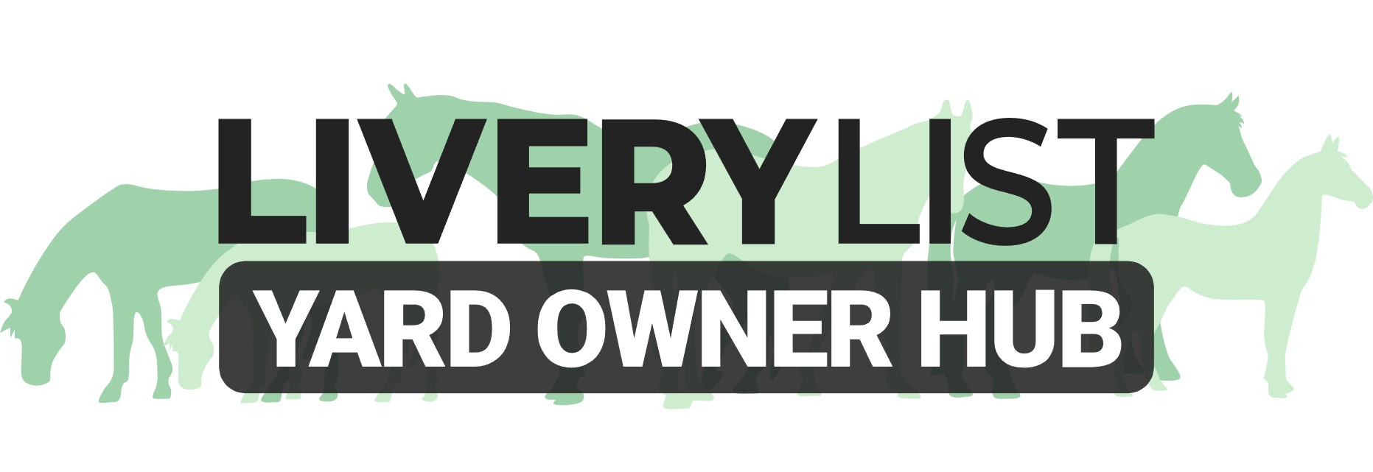
Template Livery Enquiry/ Waiting List Questionnaire

This is a template form for yard owners to provide to potential clients either upon their first enquiry, or after they show a positive interest and request to be added to a waiting list. This gives yard owners the opportunity to have the details to consider applications for vacancies, and to contact the potential client.

If you are holding a space it is advised to secure a deposit from the client, and to provide them with a receipt clearly laying out the terms of the arrangement. A template deposit receipt can be found on the Yard Owner Hub.

[ADD YARD LOGO/ NAME]
CLIENT ENQUIRY INFORMATION FORM
OWNER DETAILS

Full Name: ……………………………………………………………………………………….
Location (town/ village): ……………………………………………………………………………………….
Contact- Home: ……………………………………………………………………………………….
Contact- Mobile: ……………………………………………………………………………………….
Email Address: ……………………………………………………………………………………….
HORSE DETAILS
Gender: ……………………………………………………………………………………….
Age: ……………………………………………………………………………………….
Breed: ……………………………………………………………………………………….
Size: ……………………………………………………………………………………….
Retired/ Ridden/ Used for: …………………………………………………………………………………………….……………………….
Vices or Health Issues: …………………………………………………………………………………………….……………………….
…………………………………………………………………………………………….……………………….
…………………………………………………………………………………………….……………………….
…………………………………………………………………………………………….……………………….
Reason for Moving Yard: …………………………………………………………………………………………….……………………….
Notice Period: ……………………………………………………………………………………….
Current yard (optional) : ……………………………………………………………………………………….
[YOU CAN ALSO INSERT ANY OTHER INFORMATION YOU FEEL WOULD BE USEFUL TO KNOW ABOUT THE CLIENT, OR THAT IT WOULD BE USEFUL FOR THE POTENTIAL CLIENT TO BE AWARE OF]

© Livery List 2023

