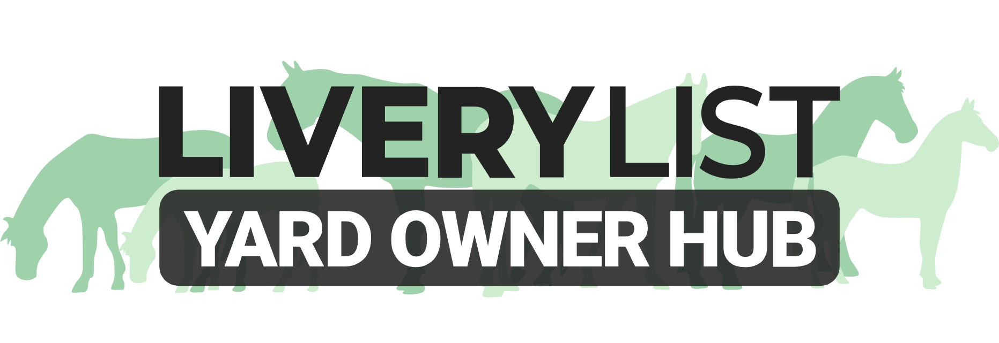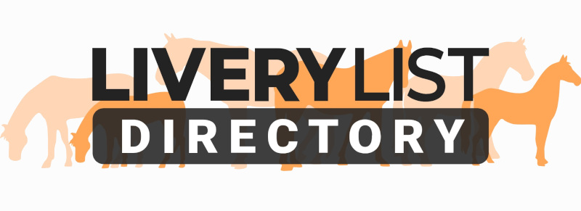
Sample Letter of Improvement
This template letter is designed as a basic outline for a livery yard to present to their client in the event that the client may be failing to meet the expectations of the livery contract.

This may include late payments, failure to provide timely or proper care to their equines, or the failure to meet contractual obligations.

This is a guide only and the changes to the letter should be edited to reflect the specific circumstances or clauses in your livery contract with the failures. The time frame given for improvements should also be realistic. Dependant upon the type of failure, you can also amend the potential actions to be taken should these failures continue.

Selecting the relevant scenario, amendments can be added or removed as appropriate to make the letter as concise or simple as required, although it is advised to keep to fact and to keep the letter short and uncomplicated. Remembering to remove the unnecessary information before issuing. The items highlighted in bold indicate common areas to be personalised.

[ENTER YOUR BUSINESS NAME AND ADDRESS]
[ENTER CLIENTS NAME AND ADDRESS]
[ENTER DATE]
Reference: Request for Improvement [AMEND AS NECESSARY]
Dear [ENTER LIVERY CLIENTS NAME],

I am writing to advise of/ confirm [AMEND AS NECESSARY] that as per the terms of your livery contract at [ENTER YARD NAME], we request improvements to be made in order for the arrangement to continue.

SCENARIO 1: Late Payment
As per the terms of our livery contract, payments should be made in full at month end. Any late payments risk the termination of contract, and continued failure to pay monies owed may result in notice being served, and action being taken to recoup any losses. We would therefore request that you bring your attached account [ATTACH A STATEMENT OF ACCOUNT] up to date by [ENTER DATE- RECOMMENDED IN LINE WITH NEXT PAYMENT DEADLINE OR 30 DAYS MAXIMUM]. After this period has lapsed, failure of payment to be made will result in notice being served and all rights associated with your livery contract being terminated in full. Any outstanding monies owed will then be sought, plus interest as necessary.

SCENARIO 2: Welfare Concerns
As per the terms of our livery contract, there is a level of expectation in relation to the care of equines on our premises. On a regular basis, we believe that there have been failures on the standards of care for [ENTER NAME OF HORSE/S]. Our concerns include [ENTER BRIEF DESCRIPTION OF CONCERNS- i.e. stabled too long, underfed, not receiving correct basic care]. We have verbally pointed out these concerns to you but there does not appear to be visible improvement. As the Yard Owners, we have a duty of care to equines on our premises. We would therefore request that you actively make an ongoing improvement to alleviate these concerns, and we give 30-days’ notice [AMEND AS NECESSARY] from the date of this letter for such improvements to be made. After this period has lapsed, failure of improvement will result in notice being served, and all rights associated with your livery contract being terminated in full.

SCENARIO 3: Contractual Issues
As per the terms of our livery contract, there is a level of expectation in relation to responsibilities and duties of horse owner. On a regular basis, we believe that there have been failures on your part in terms of [ENTER BRIEF DESCRIPTION OF CONCERNS- i.e. arriving late to turn out, not visiting horse as necessary, not poo picking]. We have verbally pointed out these concerns to you but there does not appear to be visible improvement. We therefore request that you actively make an ongoing improvement to alleviate these issues, and we give 30-days’ notice [AMEND AS NECESSARY] from the date of this letter for such improvements to be made. After this period has lapsed, failure of improvement will result in notice being served, and all rights associated with your livery contract being terminated in full.

Please know that you have the our full support should you be experiencing any difficulties in relation to this matter, and we would urge you to discuss with us to help remedy the situation.

Yours Sincerely,
[SIGN, ENTER YOUR NAME, BUSINESS NAME AND POSITION]

IMPORTANT
This information as provided above is intended to provide guidance and areas for consideration for those intending to enter into such arrangements. Anyone proposing to enter into such a written agreement should take consideration and their own legal advice as to their particular circumstances.

© Livery List 2024

