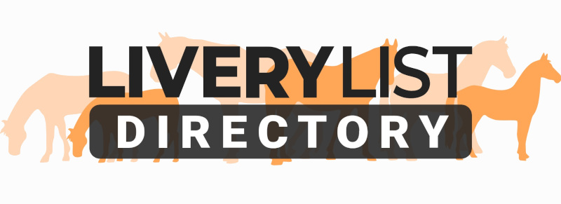
Template Horse Share Agreement
The share agreement below is a guide as to the type of agreement which would be recommended to be made between horse owner and sharer. In all cases the agreement should be edited to reflect correct information and agreements as made between the horse and the person agreeing to share it.

If your yard rules stipulate a responsibility via the sharer under the course of the horse owners livery contract with the yard owner, then it is advised to also complete the ‘Template Sharer or Loaner Livery Agreement’ or to amalgamate both documents to create a singular agreement between horse owner, loaner and yard owner.

When amended and completed with your own particulars and signed by both parties it will form a legally binding agreement. However, if the person to whom you are sharing the horse with is unknown to you, you are strongly advised to take up references and to ask a legal adviser to check the completed document.

The AGREEMENT
This agreement is made on the (Insert Date) between the parties (Insert Owner's Name & Address) (hereafter referred to as the OWNER) and (Insert Sharer’s Name and Address) (hereafter referred to as the SHARER) for the loan of (insert name of horse followed by brief description - e.g.Donny- 16.2 hand high bay gelding aged 15years approx. with white blaze and white sock) (hereafter referred to as the HORSE.)

The HORSE is to be used on the days specified as (a leisure hack/riding horse/child's pony insert as appropriate) and not for hire or reward.

The following basic terms have been agreed under the share agreement:

The SHARER has full access to the horse for (Insert number of days) days per week. These days are fixed to Monday, Wednesday and Sunday. Any change to these dates- permanent or otherwise- must be confirmed in writing.

During these days the SHARER has full responsibility of the HORSE which includes the following duties:
- Turning out in the morning, bringing in in the evening and changing rugs as appropriate,
- Mucking out the stable, filling hay and water,
- Preparing feeds for that evening and the following morning,
- Exercise of the horse.

If for any reason the SHARER is unable to attend to the HORSE on agreed days the OWNER must be informed and/ or alternative arrangements made for care of the horse.

The SHARER has agreed to pay the OWNER the sum of (Enter price in £) per calendar month for the share of the HORSE. These payments must be made in full in advance by the 1st of the month.

The following additional conditions apply to the share agreement:

(1) The share period will start on (Insert Date) and continue for a period of (Insert Duration) until (Insert Date) when the share agreement may be:
1.1) Extended for a period of time to be agreed between the parties or
1.2) Full responsibility for the HORSE is to be returned to the OWNER. (Delete or amend if required.)

(2) The share agreement may be terminated on or before this date if:
2.1) The SHARER no longer wishes to share the HORSE. The SHARER will inform the OWNER no less than 7 days before the agreement may be terminated.
2.2) The OWNER believes the HORSE is not being treated or looked after in the correct manner by the SHARER. The OWNER may at his own discretion give the SHARER a specific period of time during which the SHARER must rectify any reasonable issues that the OWNER may have.

The OWNER will notify the SHARER if the horse suffers any illness or injury which renders it unsuitable for use for any period of time and the share agreement may be suspended during this period.

(3) The HORSE is to be kept at (Insert livery yard/farm/borrower's premises as applicable). The SHARER must abide by the rules of the yard at all times.

(4) It is understood by the LOANER that the HORSE….. (examples - insert own particulars as applicable)

- must not be left in a field on its own, he must have company at all times,
- has a tendancy to rear in hand so precautions should be taken,
- has been known to react / spook badly as large vehicles such as lorries and buses.
(or anything else the BORROWER needs to know to safeguard both the horse's health and well-being and his own.)

(5) The BORROWER is responsible for ensuring prompt and required veterinary treatment by a registered and qualified veterinarian should this be necessary. In all cases the SHARER should first attempt to contact the OWNER. Responsibility for payment of the aforesaid veterinary treatment lies solely with the OWNER unless the injury or cause of illness was a direct result of actions taken by the SHARER in which case the SHARER may be liable to pay towards the cost of veterinary treatment.

(6) It is understood by the OWNER that he is responsible for ensuring that the HORSE is fully insured for all activities both they and the SHARER intend to partake in. Liability for payment of the aforesaid insurance lies solely with the OWNER.

(7) It is understood by the OWNER that he is responsible for ensuring that the HORSE is suitably shod at all times and the liability for payment of the aforesaid shoeing lies solely with the OWNER.

(8) It is understood by the SHARER that that at NO TIME is he the registered OWNER of the HORSE and under no circumstances whatsoever is he permitted to Loan, Lease or Sell the HORSE to any third parties.

(9) Under the agreement the SHARER is not permitted to take the HORSE to competitions. However the SHARER is permitted to take part in activities as described below and arrangements for this should be made direct with the OWNER: (add or delete as required)
9.1) Riding Lessons
9.2) Sponsored rides
(Additional clauses can be added if under the agreement the SHARER is allowed to compete the HORSE)

(10) The following pieces of equipment will be supplied by the OWNER to the BORROWER and it is understood and agreed by the BORROWER that all items are in good working order and free from any defects not specified below. After use all equipment must be returned to the correct place and left as found. Any tack or equipment which is damaged or broken during the period of the agreement should be replaced like for like accordingly.

(11) The OWNER agrees that if a VETERINARY SURGEON advises IMMEDIATE slaughter of the HORSE to prevent further suffering in the case of severe injury and the OWNER cannot quickly be contacted the BORROWER may give permission to the VETERINARY SURGEON on the OWNER'S behalf.

Signed

……………………………………................. (THE OWNER's NAME PRINTED HERE)

…………………………………….......... (THE BORROWER's NAME PRINTED HERE)

IMPORTANT
This information as provided above is intended to provide guidance and areas for consideration for those intending to enter into such arrangements. Anyone proposing to enter into such a written agreement should take consideration and their own legal advice as to their particular circumstances.

© Livery List 2023

