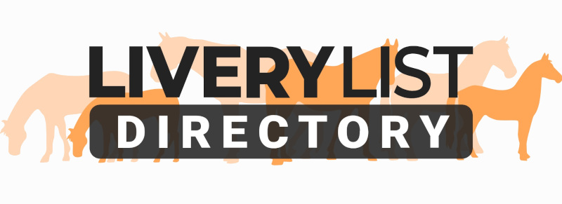
Template Horse Loan Agreement
The template loan agreement below is a guide as to the type of agreement which would be recommended to be made between horse owner and loaner. In all cases the agreement should be edited to reflect correct information and agreements as made between the horse and the person agreeing to take it on loan.

When amended and completed with your own particulars and signed by both parties it will form a legally binding agreement. However, if the person to whom you are loaning is unknown to you, you are strongly advised to take up references and to ask a legal adviser to check the completed document.

It is recommended that the signing of the agreement should be witnessed by two witnesses, one known to each party. The owner and loaner should each retain a signed copy of the agreement.

The AGREEMENT

This agreement is made on the (Insert Date) between the parties (Insert Owner's Name & Address) (hereafter referred to as the OWNER) and (Insert Loaner Name and Address) (hereafter referred to as the LOANER) for the loan of (insert name of horse followed by brief description - e.g.Donny- 16.2 hand high bay gelding aged 15years approx. with white blaze and white sock) (hereafter referred to as the HORSE.)

The HORSE is to be used as (a companion/riding horse/child's pony insert as appropriate) and not for hire or reward.

(1) The loan period will start on (Insert Date) and continue for a period of (Insert Duration) until (Insert Date) when the loan agreement may be:
1.1) Extended for a period of time to be agreed between the parties or
1.2) The HORSE is to be returned to the OWNER. (Delete or amend if required.)

(2) The Loan may be terminated on or before this date if (Delete or amend if required.):
2.1) The LOANER no longer wishes to loan the HORSE. The LOANER will inform the OWNER in writing, no less than 30 days before the HORSE and all associated equipment in (13) will be returned in a good condition to the OWNER.
2.2) The OWNER has decided to sell the HORSE. The LOANER will inform the OWNER in writing, no less than 30 days before the HORSE and all associated equipment in (13) will be returned in a good condition to the OWNER.
2.3) The OWNER believes the HORSE is not being treated or looked after in the correct manner. The OWNER may at his own discretion give the LOANER a specific period of time during which the LOANER must rectify any reasonable issues that the OWNER may have. The OWNER hereby reserves the right to remove the HORSE at his own expense from the LOANER with no notice whatsoever.

(3) The HORSE is to be kept at (Iinsert livery yard/farm/loaners premises as applicable) unless it is agreed by the OWNER in writing that the HORSE may be moved to alternate accommodation.

(4) The LOANER will allow the OWNER access to the HORSE at the address specified in (3) at any reasonable time in order that OWNER may check that the horse is in good health subject to the access and visiting protocols permitted by the premises.

(5) It is understood by the LOANER that the HORSE….. (examples - insert own particulars as applicable)

- must not be left in a field on its own, he must have company at all times,
- has COPD & can't be bedded down on straw,
- was last wormed on 13th January 2011 with Equest,
- has a tendancy to rear in hand so suitable precautions should be taken,
- has been known to react/ spook badly to large vehicles such as lorries and buses,
(or anything else the LOANER needs to know to safeguard both the horse's health and well-being and his own.)

(6) The LOANER is responsible for ensuring prompt and required veterinary treatment by a registered and qualified veterinarian which includes routine and timely vaccinations for flu and tetanus (& anything else your horse is vaccinated against) for the HORSE at all times and the liability for payment of the aforesaid veterinary treatment lies solely with the LOANER. The LOANER will notify the OWNER if the horse suffers any serious illness or injury and will notify the owner in advance if possible of any requirement for the HORSE to have surgery or general anaesthetic.

(7) It is understood by the LOANER that he is responsible for ensuring that the HORSE is fully insured for all activities they intend to partake in. veterinary treatment, third party liability, travelling, saddlery and tack at all times for its full value and the liability for payment of the aforesaid insurance lies solely with the LOANER. If the LOANER fails to insure the HORSE and its effects the LOANER assumes full liability for any loss or damage, including 3rd party legal liability. (or amend as necessary. NB The OWNER may have to arrange the insurance and reclaim the premium from the LOANER, consult your insurer.)

(8) The HORSE is not permitted to take part in any of the below mentioned activities under any circumstances whatsoever: (add or delete as required)
10.1) Polo
10.2) Hunting
10.3) Any other activities of any kind not covered under the INSURANCE

(9) It is understood by the LOANER that he is responsible for ensuring that the HORSE is suitably shod at all times and the liability for payment of the aforesaid shoeing lies solely with the LOANER.

(10) The LOANER understands that to prevent the risk of infectious disease or illness to the HORSE, they must take the necessary cautions with regards to biosecurity when visiting events, shows or coming into contact with other equines.

(11) It is understood by the LOANER that that at no time are they the registered owner of the HORSE and under no circumstances whatsoever is he permitted to Loan, Lease or Sell the HORSE to any third parties.

(12) The HORSE has been accompanied by a passport issued by (Insert Passport Issuing Authority) and has the unique identification number (Insert Passport Number). The LOANER must ensure that the passport accompanies the HORSE at all times during transportation and that the LOANER follows any necessary requirements for the premises detailed in (3) in relation to Equine ID rules (ie if it is necessary to leave at the yard in care of the yard owner). At all times the ownership of both the HORSE and the passport remain with the OWNER.

(13) The following pieces of equipment will be supplied by the OWNER to the LOANER and it is understood and agreed by the LOANER that all items are in good working order and free from any defects not specified below. The LOANER agrees that at the time of termination of the contract, all the equipment listed below will be returned to the OWNER in good working order. Any tack or equipment which is damaged or broken during the period of the agreement should be replaced like for like accordingly.

13.1) Saddle (state make, size, colour, condition, approx. value and any security marks)
13.2) Bridle (state make, size, bit, colour, condition, approx. value and any security marks)
13.3) Rugs (State quantity, size, type, colour, repairs etc)
(Insert anything else that you give with the horse but it MUST be listed
specifically to ensure any chance of seeing it again.)

(14) The OWNER agrees that if a VETERINARY SURGEON advises IMMEDIATE slaughter of the HORSE to prevent further suffering in the case of severe injury and the OWNER cannot quickly be contacted the LOANER may give permission to the VETERINARY SURGEON on the OWNER'S behalf.

(15) Any changes to this contract must be made in writing and signed by both parties.

(16) Two copies pf this agreement shall be copied, one to be retained by the OWNER and the other by the LOANER. No changes may be made to the terms of this agreement unless made by prior written agreement between the LOANER and OWNER.

Signed

……………………………………................. (THE OWNER's NAME PRINTED HERE)

Witnessed by

................................................................................. (Insert Witness's name & address here)

…………………………………….......... (THE LOANERS NAME PRINTED HERE)

Witnessed by

……………………………………............................... (Insert Witness's name & address here)

IMPORTANT
This information as provided above is intended to provide guidance and areas for consideration for those intending to enter into such arrangements. Anyone proposing to enter into such a written agreement should take consideration and their own legal advice as to their particular circumstances.

© Livery List 2023

